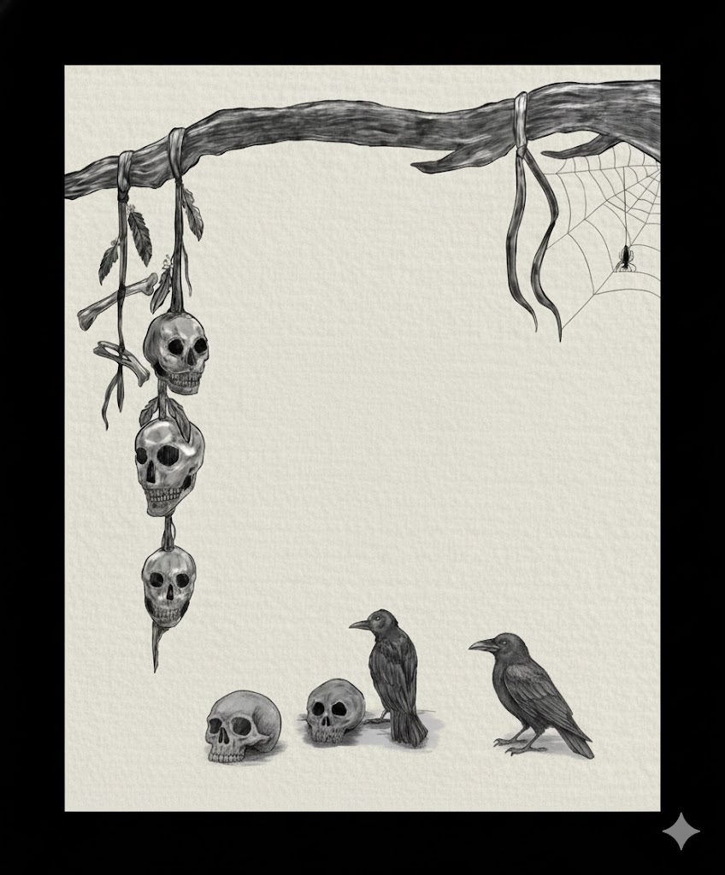
Your Book Title

Publication mart
1STEdition - 2025
ISBN xxx-x-xxxxx-xx-x
This book has been published with all reasonable efforts taken to make the material error-free after the consent of the author. No part of this book shall be used, reproduced in any manner whatsoever without written permission from the author, except in the case of brief quotations embodied in critical articles and reviews.
The Author of this book is solely responsible and liable for its content including but not limited to the views, representations, descriptions, statements, information, opinions and references [“Content”]. The Content of this book shall not constitute or be construed or deemed to reflect the opinion or expression of the Publisher or Editor. Neither the Publisher nor Editor endorse or approve the Content of this book or guarantee the reliability, accuracy or completeness of the Content published herein and do not make any representations or warranties of any kind, express or implied, including but not limited to the implied warranties of merchantability, fitness for a particular purpose. The Publisher and Editor shall not be liable whatsoever for any errors, omissions, whether such errors or omissions result from negligence, accident, or any other cause or claims for loss or damages of any kind, including without limitation, indirect or consequential loss or damage arising out of use, inability to use, or about the reliability, accuracy or sufficiency of the information contained in this book
To update the Table of Contents, please right-click the field and choose ‘Update Field’ and ‘Update Entire Table.’ When you update the Contents field, the fonts would automatically change to the default ‘Calibri’ setting given by Word. You can manually select the text and change the font to ‘Gandhi serif.’ Please delete these instructions once you update the Table of Contents. For more details, please go through the Reference Guide.
Foreword……………………………………………………………………………………………………………. iv
Preface ……………………………………………….…………………………………………………………………v
Acknowledgments………………….…………………………………………………………………………….vi
Prologue/Introduction ………………………….………….…………………….……………………………vii
Chapter name 1 ……………………………………….……………..…………………………………………….8
Chapter name 2 ……………………………………………………………….…………………………………….9
Chapter name 3 …………………………………………………………………….……………………………..10
Chapter name 4 ……………………………………………………………………………………………………11
The Arrival ……………………………………………………………………………………………………..…11
Whispers in the Walls …………………………………………………………………………………….…11
The Reflection ………………………………………………………………………………………………….11
The One Who Remains …………………………………………………………………………………….11
Chapter name 5 …………………………………………………………………………………………………….12
The Inheritance ……………………………………………………………………………………………..12
Scratching Sounds …………………………………………………………………………………………12
The Locked Room ………………………………………………………………………………………….12
The Thing That Listens …………………………………………………………………………………..12

Foreword
A Foreword is a short introduction to the book, usually by a person other than the author. The purpose of the Foreword is to introduce the author or his/her work.
A Foreword could talk about why the book’s content is relevant in its current scenario or how it created a historical impact when it was first released or the importance of the author’s work.
As you can see here, the first paragraph is usually given a flush left alignment (Normal_without indent) and all subsequent paragraphs are given a slight indent (Normal_indent). The first paragraph of a new section after a subheading should also be given a flush left alignment. This rule applies to all chapters in the book.
Headers in the front matter of the book contain the name of the chapter alone. Pages in which the chapter starts would not have headers or footers.
The Foreword is usually signed by its writer with his/her credentials and the date. You can delete this page if you do not wish to include a Foreword in the book.

Preface
The Preface is an introductory passage to the book, which is written by the author. It could talk about how the story came into being, the purpose of the book, its main characters, the author’s journey of writing the book, etc.
As you can see here, the first paragraph is usually given a flush left alignment (Normal_without indent) and all subsequent paragraphs are given a slight indent (Normal_indent). The first paragraph of a new section after a subheading should also be given a flush left alignment. This rule applies to all chapters in the book.
Headers in the front matter of the book contain the name of the chapter alone. Pages in which the chapter starts would not have headers or footers.
The Preface is usually signed by the author with the date. You can delete this page if you wish to not include a Preface in the book.
We’ve added additional text in this section to show you how the headers and footers appear in the subsequent pages. Please delete the instructions and the additional text when you add the actual content of the book.

Acknowledgments
The Acknowledgments page is usually written by the author to publically thank people who have contributed to the book.
Acknowledgments in some books run on for pages, but it is generally considered good practice to limit this section to a page, so that readers are not tempted to overlook it entirely.
As you can see here, the first paragraph is usually given a flush left alignment (Normal_without indent) and all subsequent paragraphs are given a slight indent (Normal_indent). The first paragraph of a new section after a subheading should also be given a flush left alignment. This rule applies to all chapters in the book.
Headers in the front matter of the book contain the name of the chapter alone. Pages in which the chapter starts would not have headers or footers.
You can delete this page if you do not wish to include an Acknowledgments page in the book.
We’ve added additional text in this section to show you how the headers and footers appear in the subsequent pages. Please delete the instructions and the additional text when you add the actual content of the book.

Prologue/Introduction
A Prologue, in case of fiction books, can be an excerpt from the book or a section of the story that happens before the true beginning of the story. It could provide readers an introduction to the nature of the characters in the story, a view of events that happened earlier and also set the tone of the book.
An Introduction, in case of non-fiction books, defines what the book is about, what a reader can expect from the book, the motivation for the book and, sometimes, guidance on how to use the book.
As you can see here, the first paragraph is usually given a flush left alignment (Normal_without indent) and all subsequent paragraphs are given a slight indent (Normal_indent). The first paragraph of a new section after a subheading should also be given a flush left alignment. This rule applies to all chapters in the book.
Headers in the front matter of the book contain the name of the chapter alone. Pages in which the chapter starts would not have headers or footers.
You can delete this page if you do not wish to have a Prologue or Introduction in the book.

Chapter name 1
The house at the end of Black Hollow Lane had been empty for years, yet every night a single lamp glowed behind its cracked windows. No one remembered who built it, only that screams once echoed there and were never answered. When Arjun inherited the property, curiosity outweighed fear. On his first night inside, the walls whispered his name, softly at first, then with growing urgency.
As midnight struck, the temperature dropped sharply. Footsteps echoed above him, slow and deliberate, though the upper floor had collapsed decades ago. In the mirror across the hallway, a shadow appeared behind him—tall, faceless, and breathing. When Arjun turned, nothing was there, but the mirror now showed him smiling… though he wasn’t.

Chapter name 2
Unable to sleep, Arjun searched the house records and found a single line repeated on every page: The house does not let go. At dawn, he tried to leave, but the front door led back into the hallway. The whispers returned, louder now, pleading for company.
By nightfall, the lamp still burned. Neighbors passing by swore they saw two figures standing at the window—one watching the road, the other trapped behind the glass, screaming silently to be let out.

Chapter name 3
Video provides a powerful way to help you prove your point. When you click Online Video, you can paste in the embed code for the video you want to add. You can also type a keyword to search online for the video that best fits your document.
To make your document look professionally produced, Word provides header, footer, cover page, and text box designs that complement each other. For example, you can add a matching cover page, header, and sidebar. Click Insert and then choose the elements you want from the different galleries.
Themes and styles also help keep your document coordinated. When you click Design and choose a new Theme, the pictures, charts, and SmartArt graphics change to match your new theme. When you apply styles, your headings change to match the new theme.
Save time in Word with new buttons that show up where you need them. To change the way a picture fits in your document, click it and a button for layout options appears next to it. When you work on a table, click where you want to add a row or a column, and then click the plus sign.
Reading is easier, too, in the new Reading view. You can collapse parts of the document and focus on the text you want. If you need to stop reading before you reach the end, Word remembers where you left off - even on another device.

Chapter name 4

The Arrival
The house stood alone at the edge of the village, its windows dark and unblinking. Locals avoided it after sunset, claiming it remembered every voice that entered. When Ravi arrived, dust covered the floors, yet the air felt strangely warm, as if someone had just left. The door closed behind him without a sound, sealing the silence inside.

Whispers in the Walls
That night, the walls began to murmur. At first it was only fragments—broken words drifting through the corridors. Ravi pressed his ear against the plaster and heard breathing on the other side. When he spoke, the house answered, repeating his words in a slower, distorted voice that did not sound human.

The Reflection
In the hallway mirror, Ravi noticed his reflection moving a second too late. The face stared back with hollow eyes and a smile stretched too wide. He reached out to touch the glass, and cold fingers pressed back from inside, leaving dark handprints that slowly bled down the surface.

The One Who Remains
By morning, the villagers saw the lights return to the house. Ravi was never seen again. Sometimes, when the wind is right, his voice can be heard whispering warnings to those who pass—begging them not to listen.

Chapter name 5

The Inheritance
When Karthik inherited the old ancestral house, no one congratulated him. The villagers only lowered their eyes and warned him never to sleep on the ground floor. The wooden boards creaked even when no one walked on them, and at night, the house exhaled a damp, rotten breath that carried the smell of soil and decay.

Scratching Sounds
On the third night, scratching began beneath the floorboards. It was slow, deliberate, as if fingernails were searching for a way out. Karthik lifted a loose plank and found deep claw marks carved into the wood from below. When he replaced it, the scratching stopped—only to resume directly beneath his bed.

The Locked Room
At the end of the corridor stood a door sealed with rusted chains. Family records mentioned it only once: Do not open after sunset. Driven by fear and curiosity, Karthik broke the lock at midnight. Inside, the walls were covered with names—some freshly carved, still bleeding.

The Thing That Listens
A voice rose from beneath the room, whispering his name with perfect familiarity. The floor collapsed, dragging him into darkness. By morning, the house was silent again, waiting patiently for its next inheritance.

